CENTRAL INTAKE
Child and Adolescent Mental Health and Addictions Services

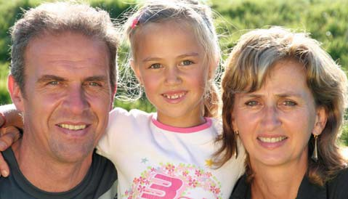
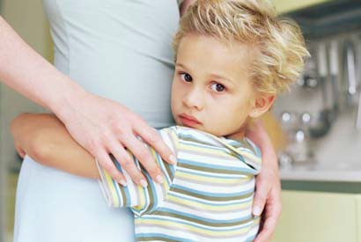
HOURS OF OPERATION

Monday to Friday
8:30 am — 4:30 pm

www.easternhealth.ca

5th Floor, Southcott Hall
Dr. L.A. Miller Centre
100 Forest Road
St. John’s, NL A1E 1E5

Telephone: 709-777-2200
Fax: 709-777-2211

www.easternhealth.ca
CENTRAL INTAKE
FOR CHILD & ADOLESCENT MENTAL HEALTH & ADDICTIONS SERVICES

Tel: 709-777-2200
Fax: 709-777-2211 www.easternhealth.ca

CENTRAL INTAKE

The Child and Adolescent Central Intake program is designed to steer in the most appropriate direction those children & youth referred for Mental Health & Addiction services. Intake Coordinators assess all referrals and determine the most appropriate intervention for a child or youth, while also considering waiting lists. Intake coordinators can also offer support and information to families & youth waiting for services.

Potential clients can go through the intake process over the phone or in person.

Central Intake also offers consultation to other professionals seeking support and information about best-practice, services, and clinical issues.
THE EASTERN HEALTH SERVICES INVOLVED IN CENTRAL INTAKE ARE

- Connect Program
- BRIDGES Program
- Community Mental Health Counsellors (Bell Island/Torbay/Portugal Cove area; CBS; Shea Heights; Ferryland & Witless Bay)
- Janeway Child & Adolescent Psychiatry
- Janeway Family Centre

All other child and

All other child and
adolescent services of Eastern Health will continue with their current intake process.

REFERRAL PROCESS

Families and Youth can refer through Central Intake by calling (709) 777-2200.

GP referrals are required for Child & Adolescent Psychiatry

Professionals can refer through Central Intake using the Mental Health & Addictions Referral Form
(www.easternhealth.ca)

Fax: 709-777-2211

